Tetra is a tool for a MCDA, where you can score alternatives for a project on various criteria of various stakeholders. The criteria differ per stakeholder and they may find some criteria to be more important than others, weighing them differently.
Tetra combines and analyses all these different stakeholders with their respective criteria and weights, to calculate the most optimal alternative. As can be seen, the optimal alternative is the MOSE-barrier
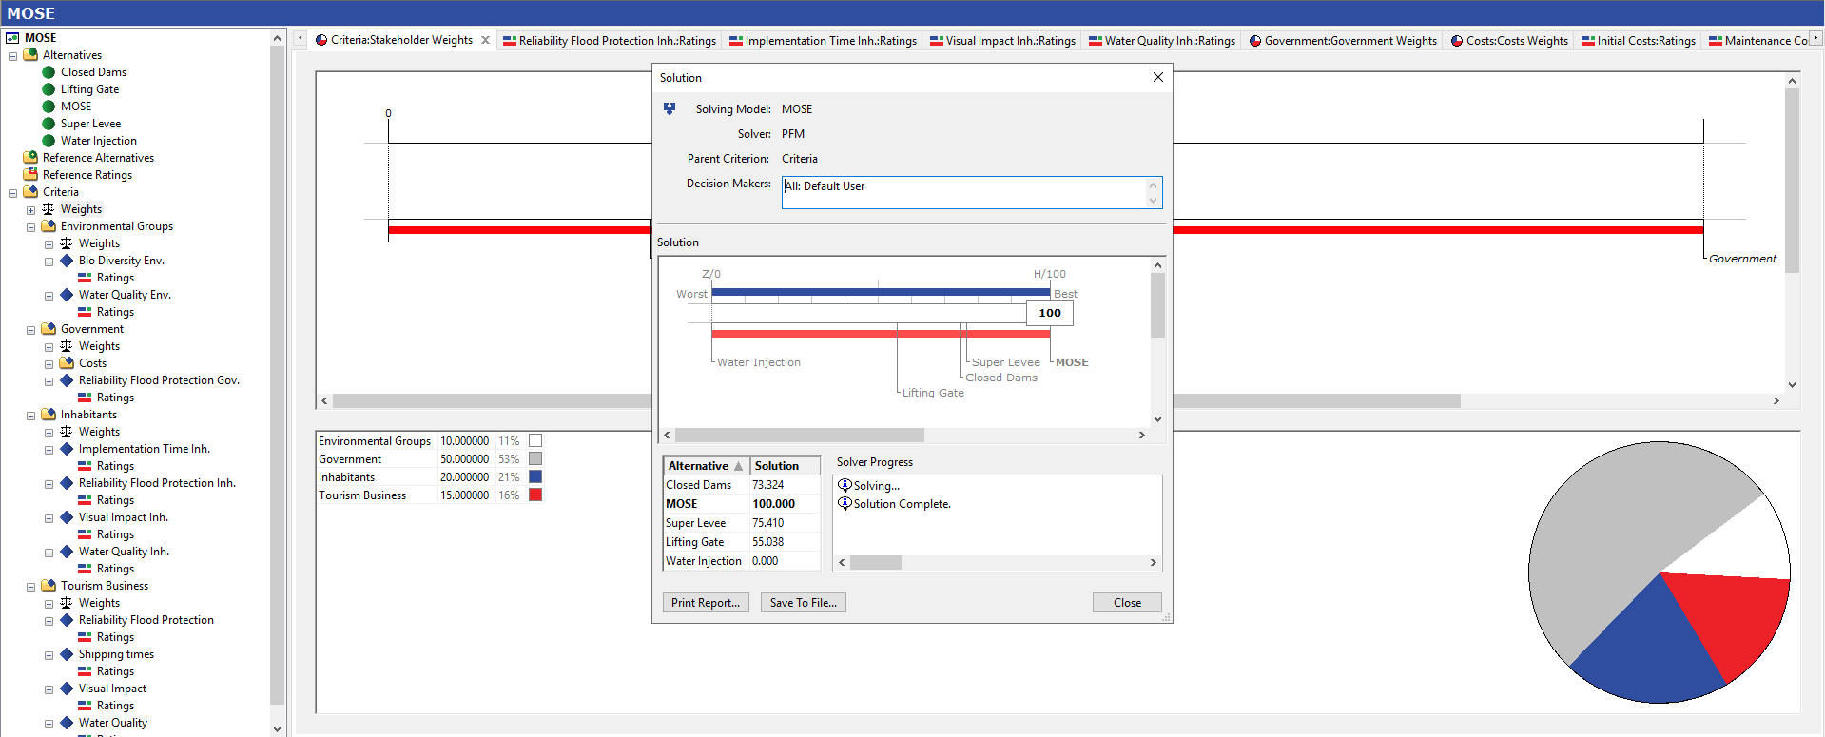

It can be interesting to perform a sensitivity-analysis, where you look at the preferred alternative of every stakeholder by setting the weight of the other stakeholders at 0. This gives us the following results:
Environmental groups
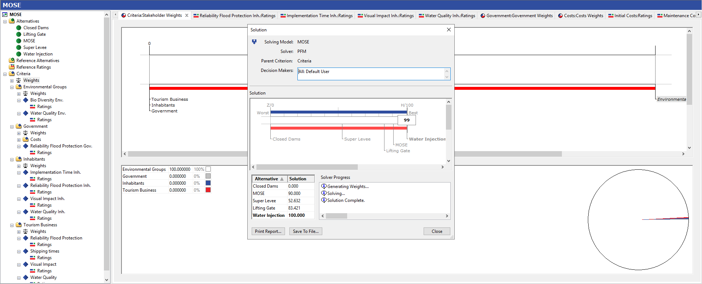

Government
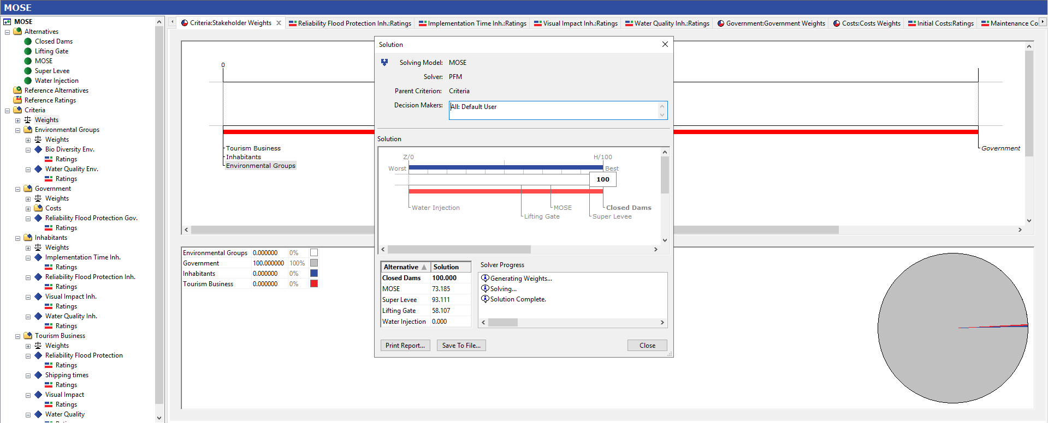

Inhabitants
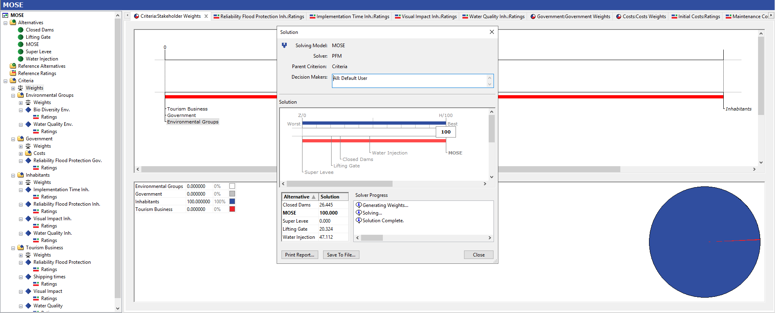

Tourism Business
